Recommendation for Restaurants

Problem Statement

Person X is trying to find a place in USA to start his own restaurant business. Every other day he went to cyber cafe to search a location where he could start his restaurant so that he gets more profit from that. After few weeks for searching when he could not find or recognize such location, he thought he should have discuss this problem with his friend 'person Y' who is expert in Data Science domain and have few years of experience of with real world data. After the discussion person Y have understand the problem and told Person X that after 2-3 days, he will figure out the way how he could solve his problem.

Background Description

After 3 days person Y calls person X that he could able to figure out to solve his problem. Person y told that he has a dataset which is not properly cleaned, may have some missing values but initially consists of 10000 restaurants with their geo location and 9 columns such as,

1. address

2. categories

3. primary categories

4. city

5. latitude

6. longitude

7. postal code

8. province

9. name of the restaurants

10. ratings

11. votes

12. and many more

Data Set Exploration

Our goal here is to predict the location suited for the new restaurant. A list of restaurants with the highest predicted ratings can then be recommended to each consumer. The restaurant ratings are numerical. Using classification techniques is also reasonable since the possible ratings are three discrete integers in this dataset. However, a three-class classification will likely predict too many ties and therefore prevent us from generating a top-n list of recommendations for a consumer. Rather than predicting the exact values of ratings that a consumer would give to certain restaurants, what is more important is predicting the ranks of these restaurants for the consumer. Thus, I will attempt to predict continuous values for the consumer ratings.

Data Methodology

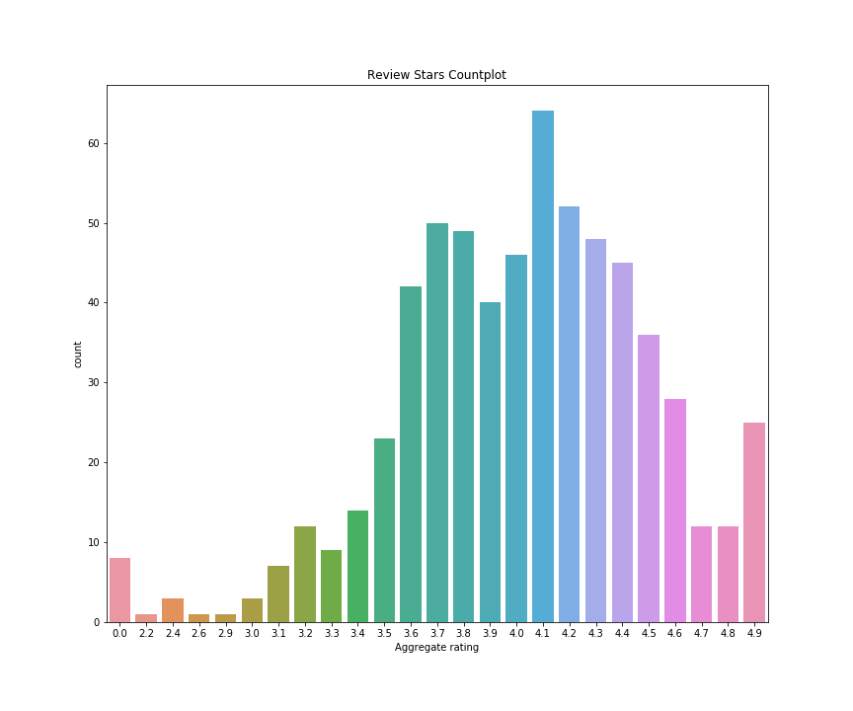

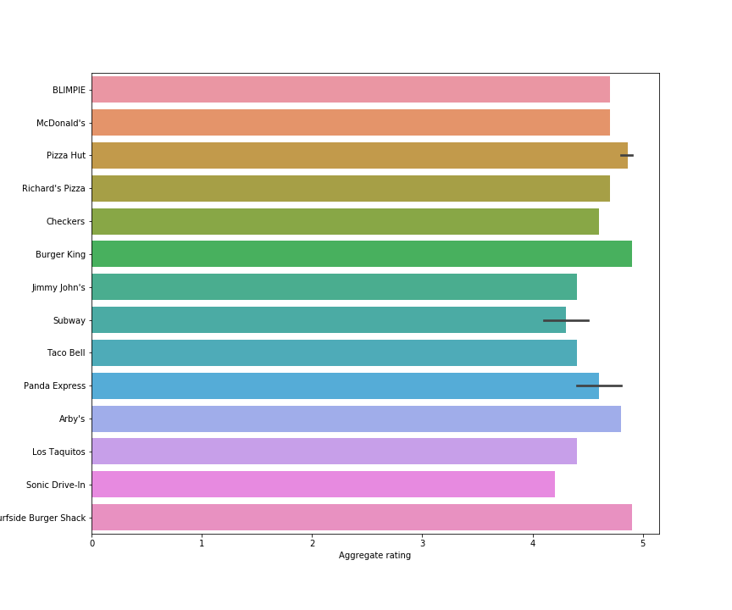

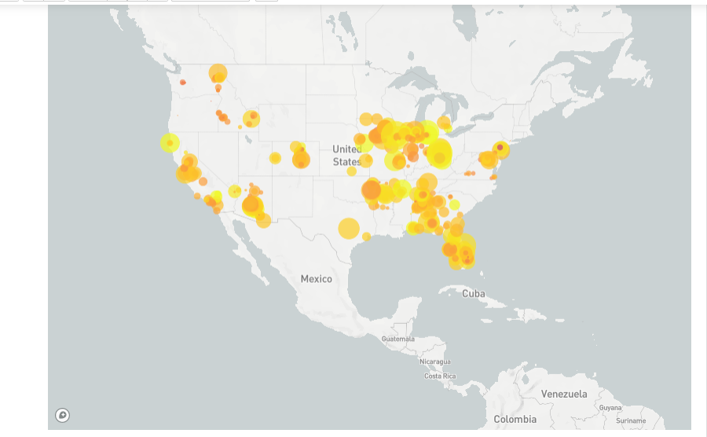

Results

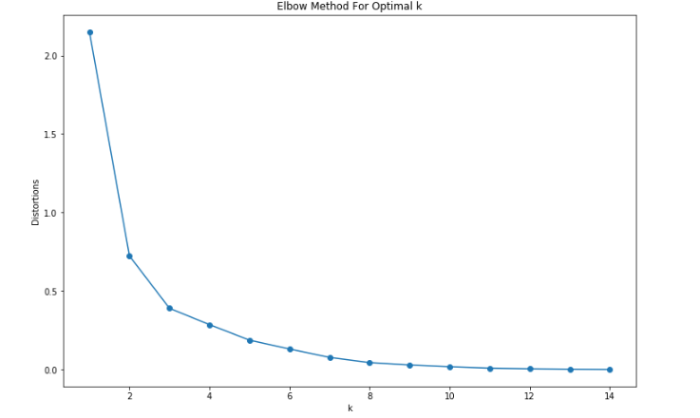

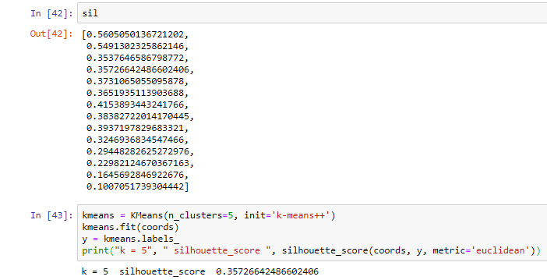

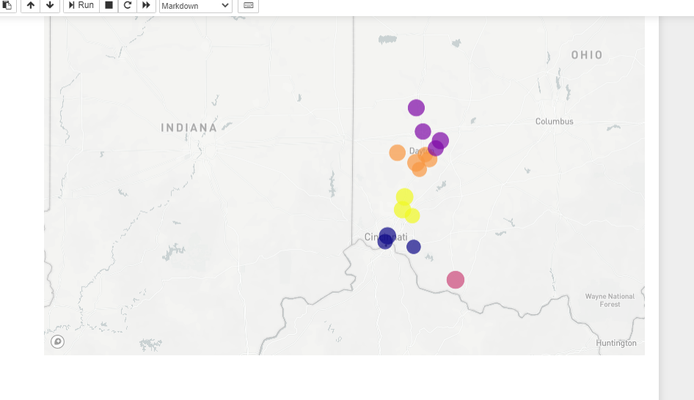

Discussion

I found the location between Cincinnati and Dayton will be a perfect place. We can also do recommendation based on the food preferred by the people who visits those restaurants frequently so that we can launch our own restaurants with those food items

Conclusion

With the of the map we can easily found the perfect location for new restaurants. we can recommend the top-n list for each user along with the restaurant information. To avoid recommending a restaurant that is too far away from the user, we can use a search radius to pre-select all the places that are within this range. These should all be straightforward, so I will just stop here.